EXPERIMENT – 14

Study and Demonstration of Brute Force Password Attack in a Controlled Kali Linux Environment

Aim
To study and demonstrate the concept of brute force password attacks in a controlled Kali Linux environment to understand password vulnerabilities and the importance of strong authentication mechanisms.

Software Requirements
- Host Operating System: Windows / Linux / macOS
- Virtualization Software: Oracle VirtualBox
- Guest Operating System: Kali Linux
- Study Tools: Open-source password auditing utilities (educational use only)
- System Requirements:
  - RAM: Minimum 4 GB (8 GB recommended)
  - Disk Space: Minimum 30 GB
  - Processor: Intel/AMD with Virtualization support

Introduction
A brute force password attack is a method where all possible password combinations are systematically tried until the correct one is found.
Such attacks exploit weak passwords, poor authentication policies, and lack of account lockout mechanisms.
Studying brute force techniques in a controlled Kali Linux environment helps learners understand real-world risks and reinforces best practices for password security and system hardening.

Procedure

Step 1: Start Kali Linux Virtual Machine
- Open Oracle VirtualBox.
- Start Kali Linux.
- Log in using Kali credentials.

Step 2: Set Up a Controlled Test Environment
- Use a locally created test account or dummy authentication service.
- Ensure no real systems or credentials are involved.
- Confirm the environment is isolated from external networks.

Step 3: Study Brute Force Attack Workflow
- Understand how login mechanisms validate credentials.
- Analyze how attackers automate repeated login attempts.
- Observe how password complexity affects attack feasibility.

Step 4: Educational Demonstration (Simulation Only)
- Simulate repeated authentication attempts using dummy data.
- Observe system responses such as delays or access denial.
- Record observations without executing real attacks.

Step 5: Analyze Security Weaknesses
- Weak or short passwords
- No rate limiting
- Missing account lockout policies
- Lack of multi-factor authentication

Step 6: Study Prevention and Mitigation Techniques
- Strong password policies
- Account lockout and rate limiting
- CAPTCHA mechanisms
- Multi-factor authentication (MFA)
- Monitoring and alerting

Output
- Understanding of brute force attack concepts.
- Identification of password-related security risks.
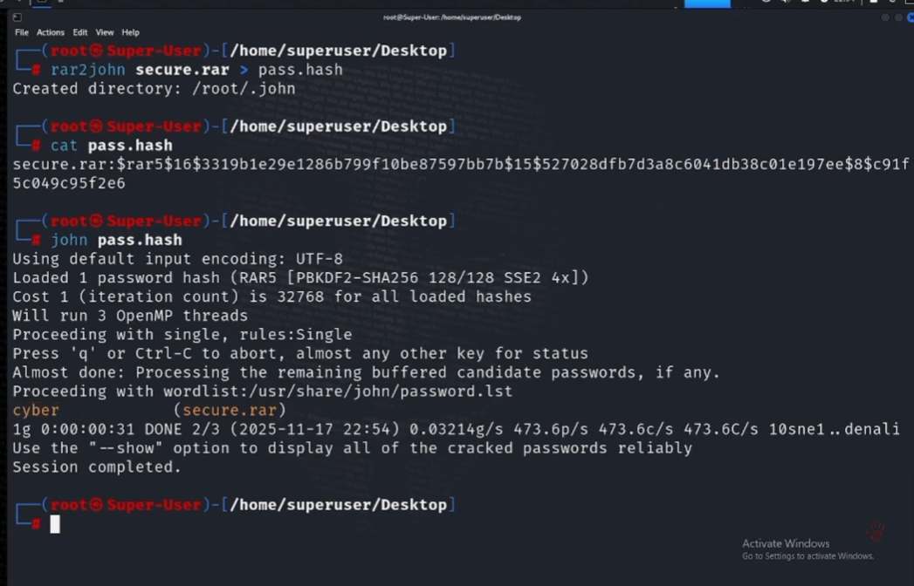

Result
The study and demonstration of brute force password attacks were successfully completed in a controlled Kali Linux environment.
The experiment emphasized the importance of strong passwords and robust authentication mechanisms to prevent unauthorized access.

Reference
https://www.kali.org
https://owasp.org

⚠️ Important Note
This experiment is conducted strictly for academic and ethical purposes using isolated test environments and dummy credentials only.
Unauthorized brute force attacks on real systems are illegal and unethical.

